National Conference on Christian Apologetics, 2016
Witnessing to Easterners

Sibu Rajappan (sibu_rajappan@yahoo.com)

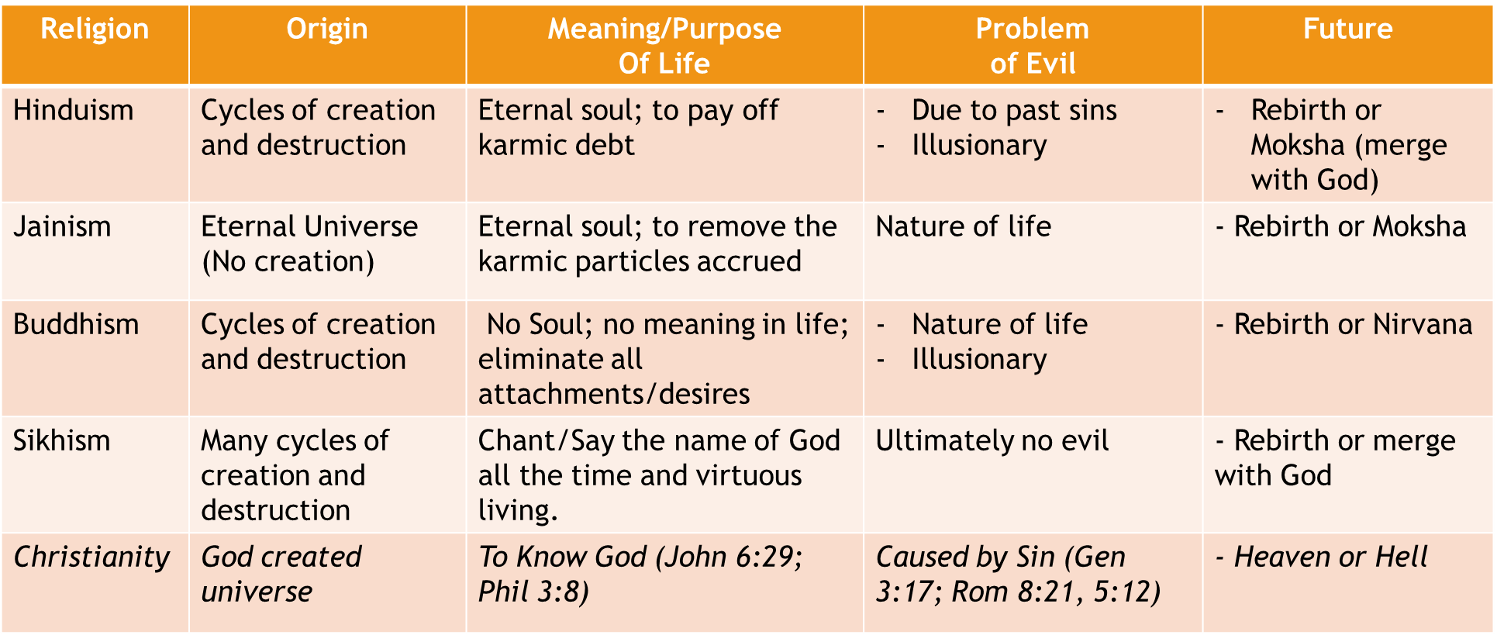
Summary of Easter Religions in comparison with Christianity

